Lesson 6 Demo 5
Azure Virtual Machine Scale Sets

Objective: You were tasked with identifying different options for deploying and configuring Azure virtual machines and making it highly available using a VM Scale set. You need to investigate compute and storage resiliency and scalability options that are available when using Azure virtual machine scale sets. You also want to explore the ability to automatically configure virtual machines and virtual machine scale sets by using the Azure Virtual Machine Custom Script extension.

Tools required: Azure account with administrator access

Prerequisites: None

Steps to be followed:
- Registering the Microsoft.Insights and Microsoft.AlertsManagement resource providers
- Deploying zone-resilient Azure virtual machine scale sets by using the Azure portal
- Configuring Azure virtual machine scale sets by using virtual machine extensions

Step 1: Registering the Microsoft.Insights and Microsoft.AlertsManagement resource providers
- Sign in to the Azure portal at https://portal.azure.com/
- Open the Cloud Shell by clicking on the first icon in the top right of the Azure Portal. If prompted, select PowerShell and then select Create storage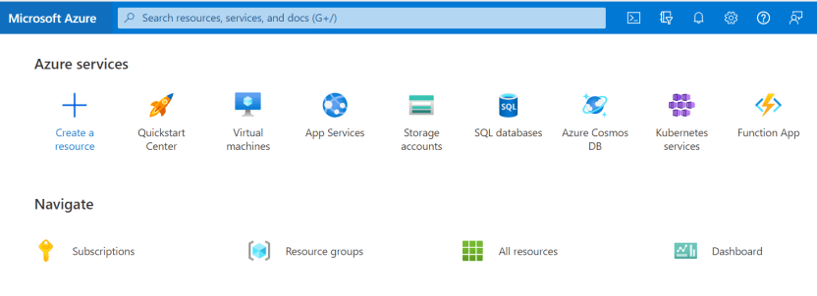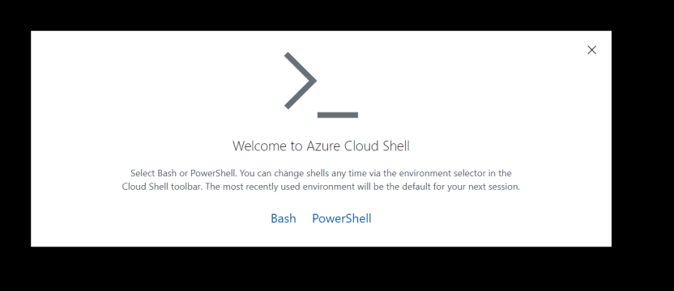
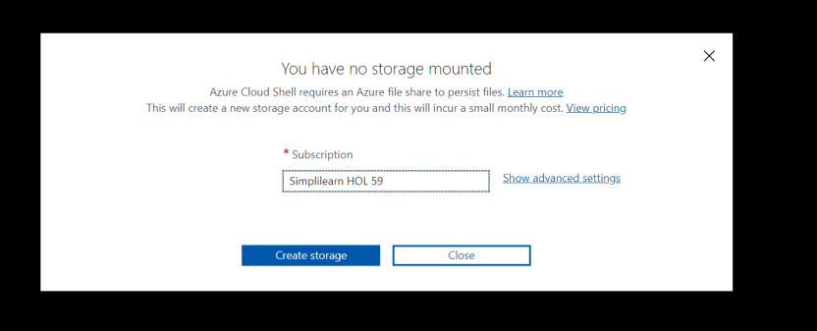

- In the PowerShell session within the Cloud Shell pane, run the following command to register the Microsoft resource providers:
Register-AzResourceProvider -ProviderNamespace Microsoft.Insights

Register-AzResourceProvider -ProviderNamespace Microsoft.AlertsManagement
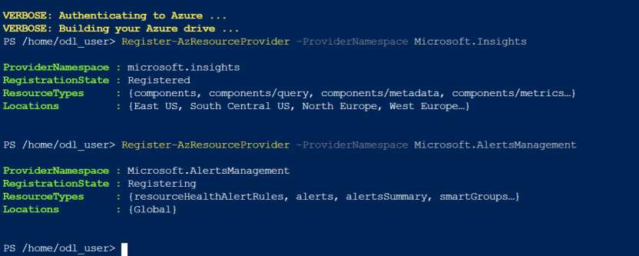

Step 2: Deploying zone-resilient Azure virtual machine scale sets by using the Azure portal

- Type Virtual machine scale sets in the search bar and select it
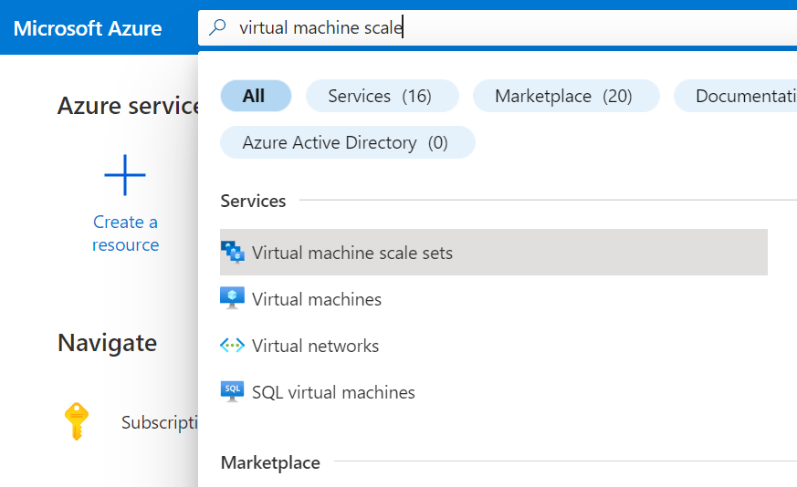

- Click on + Create
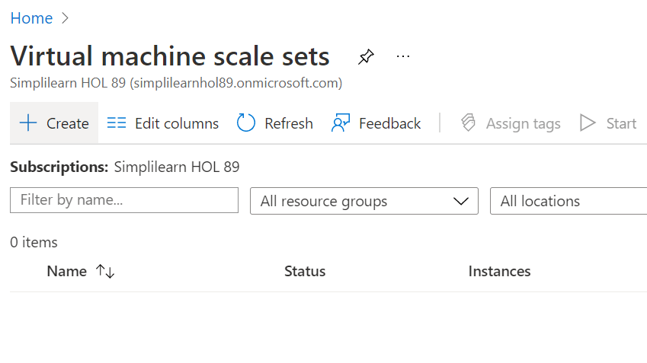

- Specify the following settings (leave others as default values):
Resource group (create new) az305-08-rg02
Name az30508vmss0
Availability zone Zones 1, 2, 3
Image Windows Server 2019 Datacenter - Gen2
Username Student
Password Pa55w.rd1234

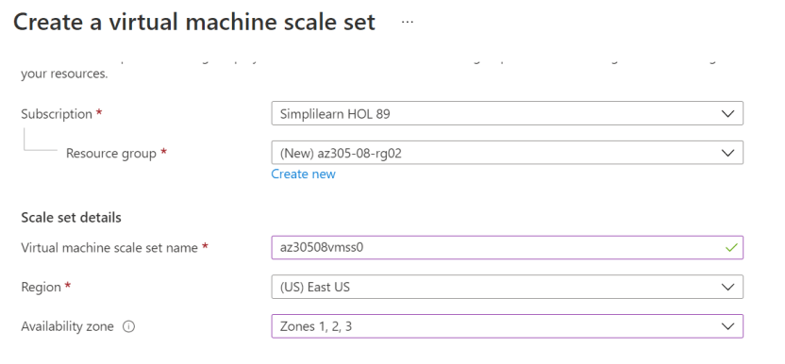
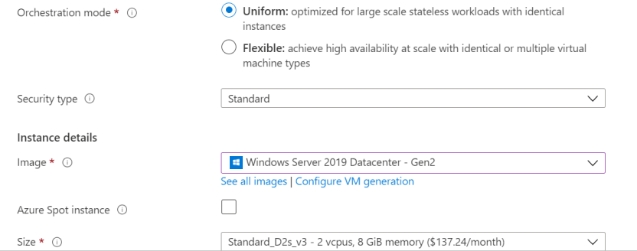
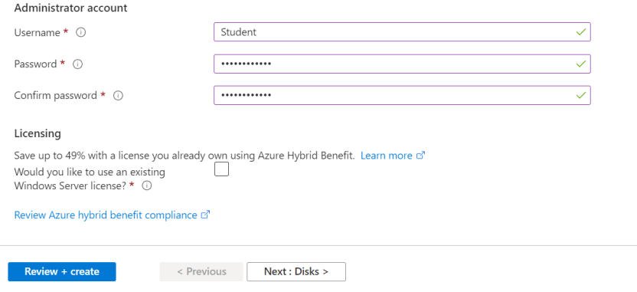

- Click on Networking
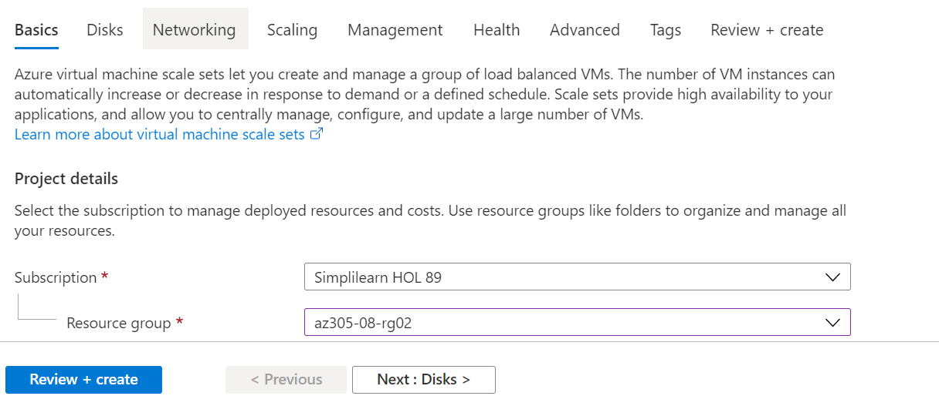
- Click on Create a Virtual network and specify the following details:
Name az305-08-rg02-vnet
Address range 10.82.0.0/20
Subnet name subnet0
Subnet range 10.82.0.0/24
- Select OK
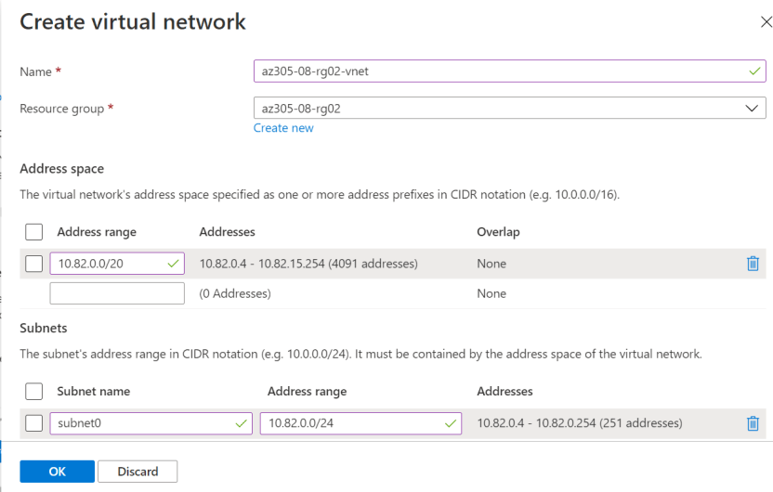

- Click on the Edit network interface icon to the right of the network interface entry
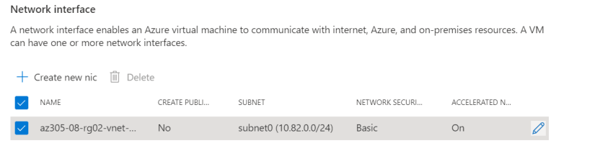

- In the NIC network security group section, select Advanced and then click on Create new
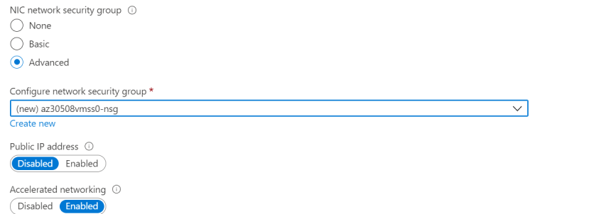
- Provide the following name:
Name az30508vmss0-nsg
- Click on Add an inbound rule and specify the following settings (leave others as default):
Destination port 80
Protocol TCP
Name custom-allow-http
- Click on Add and then click on OK
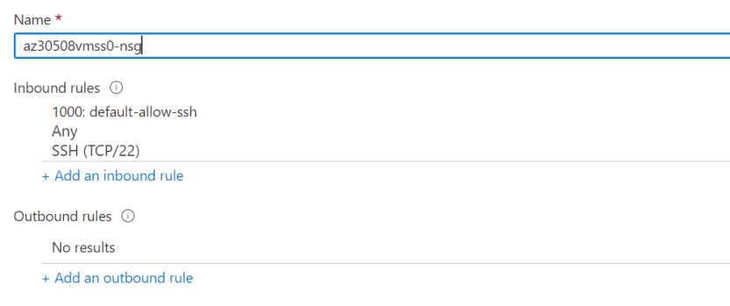
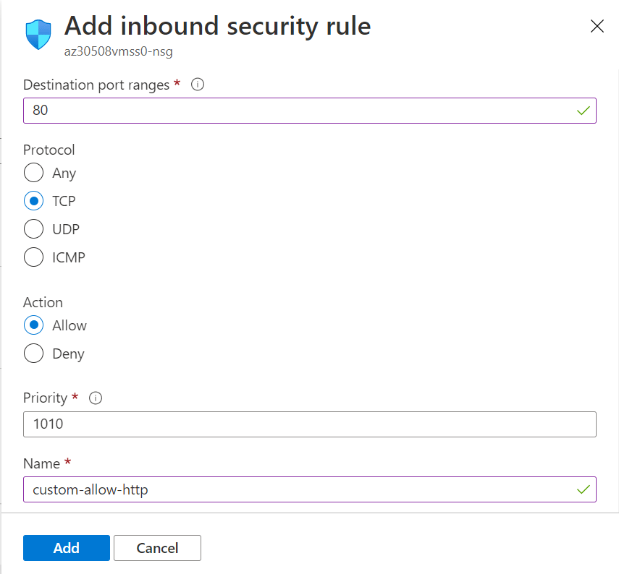

- In the Public IP address section, click on Enabled and then click on OK
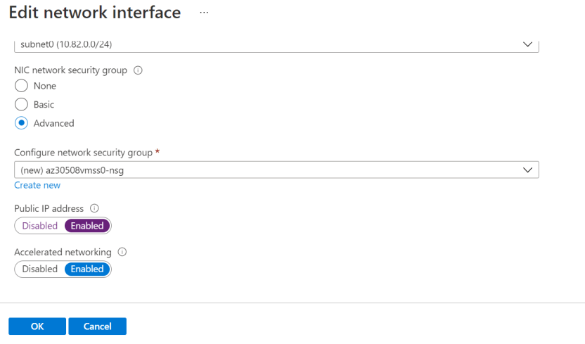

- Select Use a load balancer and then click on Next : Scaling >
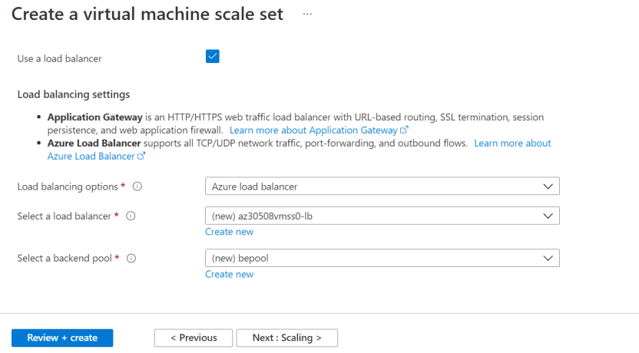

- Under the Management section, select Enable with custom storage account

- Click on Review + Create
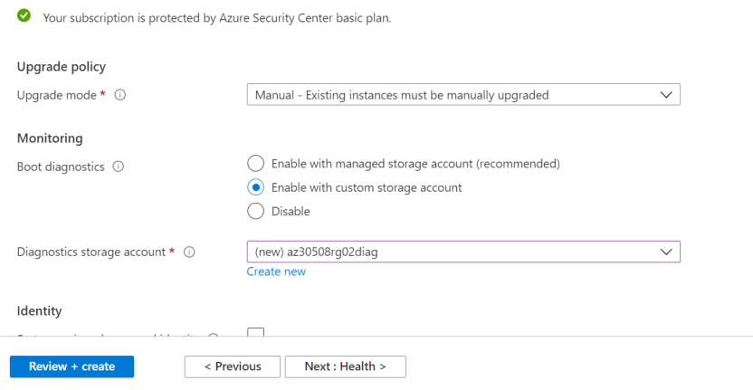

- After the validation passes, click on Create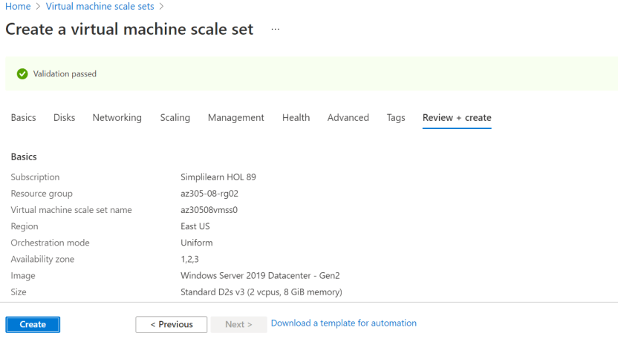

Step 3: Configuring Azure virtual machine scale sets by using virtual machine extensions
- Type Storage accounts in the search bar and select it
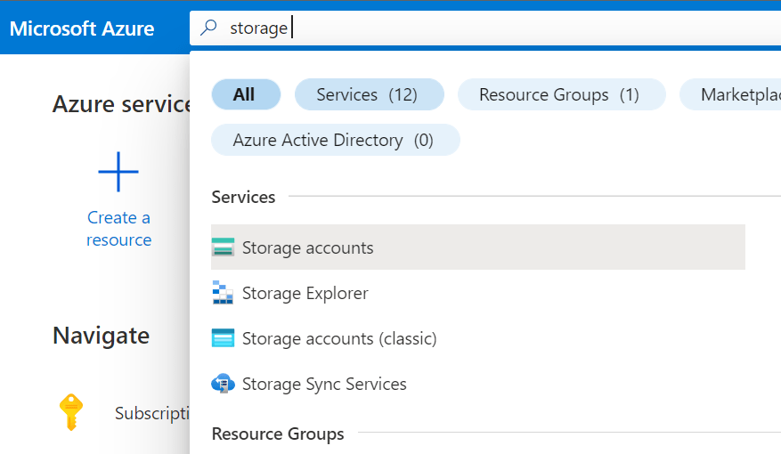

- Locate the storage account that you created and open it
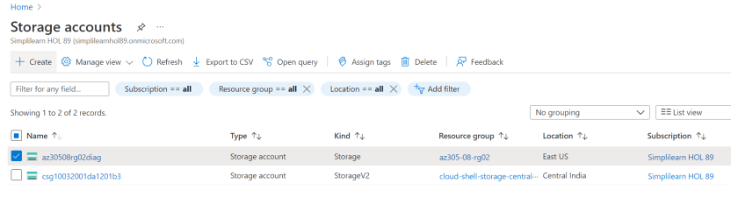

- Under the Data Storage section, click on Containers and then click on + Container
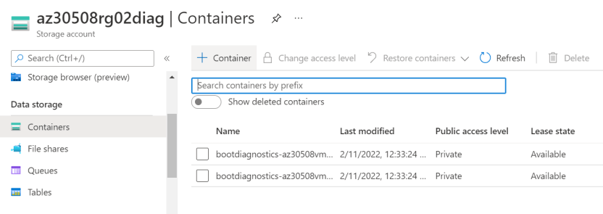
- Provide the name and then click on Create
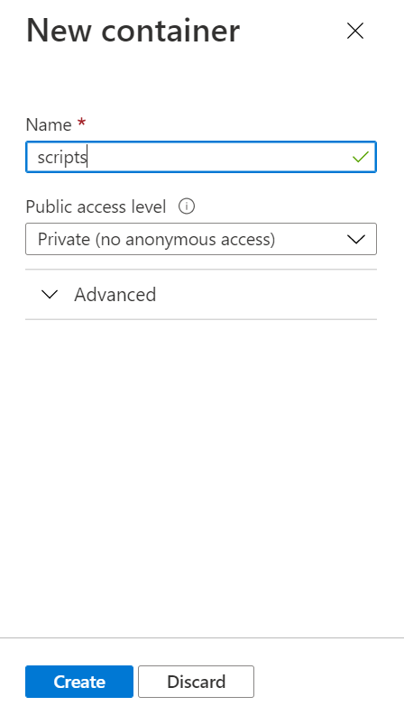

- Open the newly created container
- Click on Upload
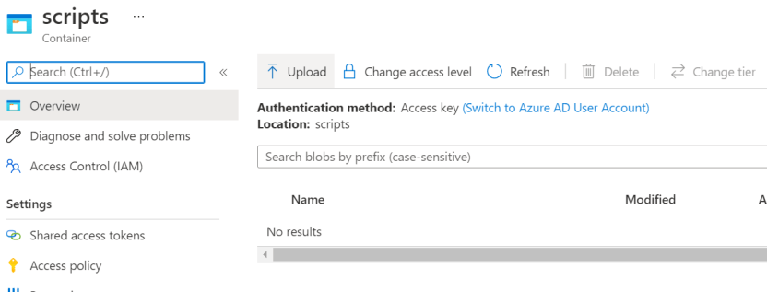

- Upload the az305-08-install_IIS.ps1 file
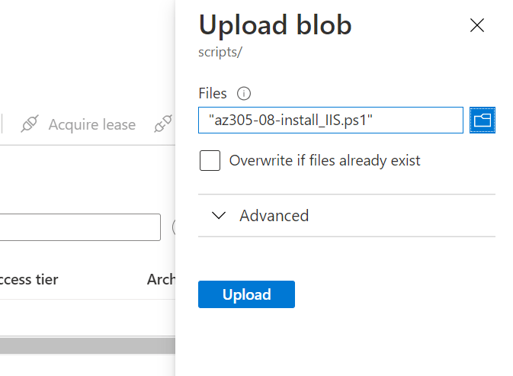

- Navigate back to the Virtual machine scale sets blade and click on az30508vmss0
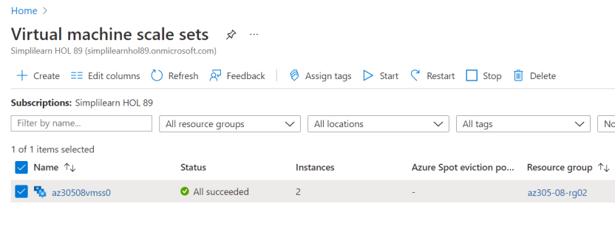

- Under the Settings section, click on Extensions and then click on + Add
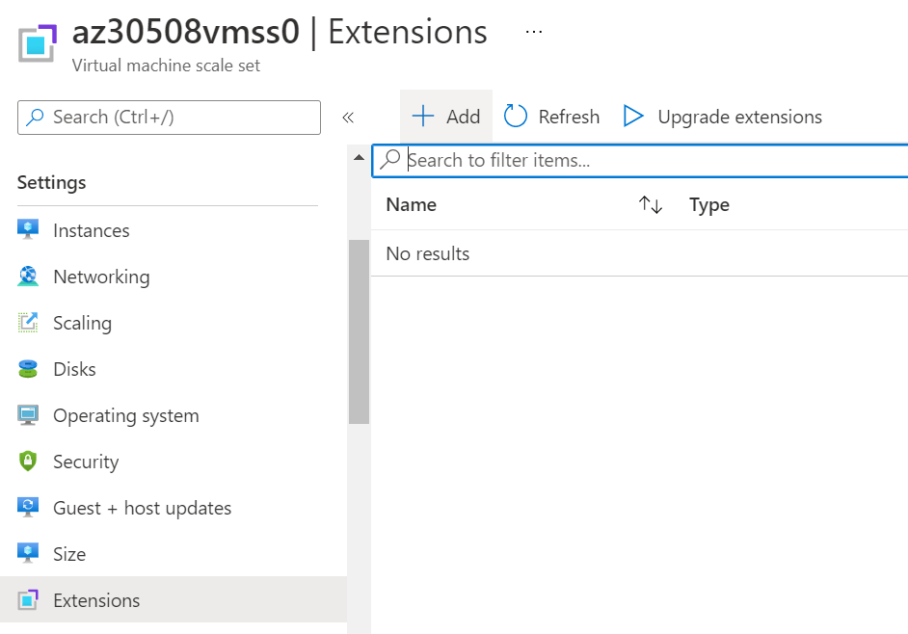

- Click on Custom Script Extension and then click on Next
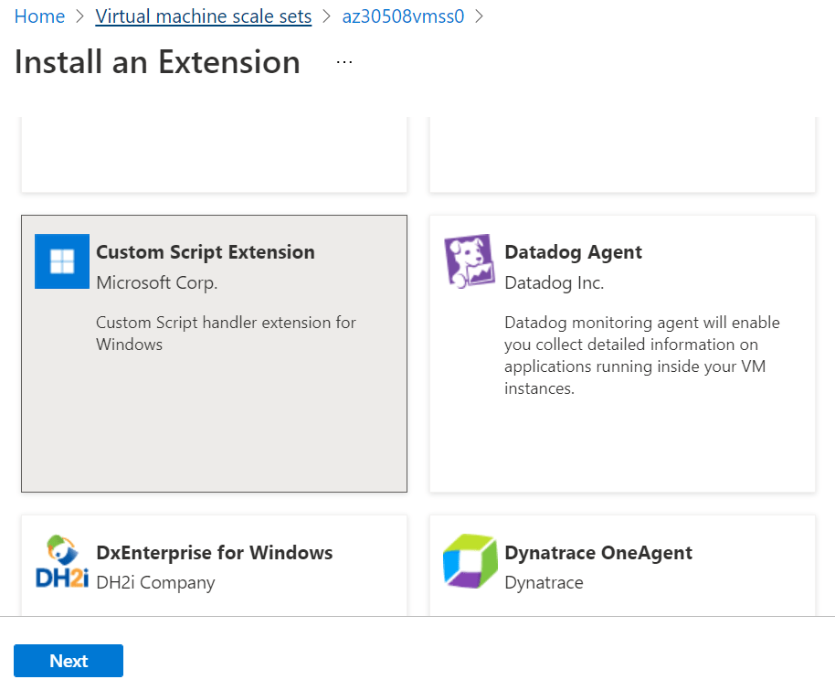

- Browse and select the az305-08-install_IIS.ps1 script that was uploaded to the scripts container in the storage account earlier in this task and then click on Create
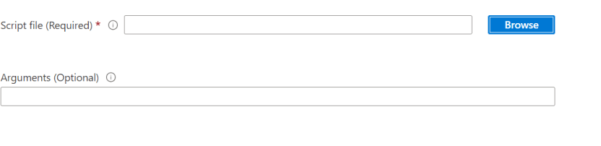
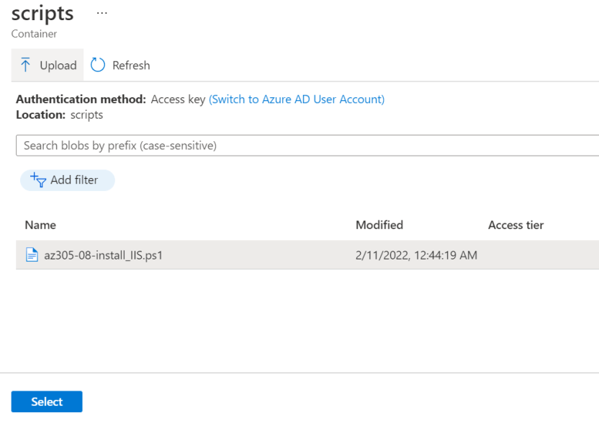
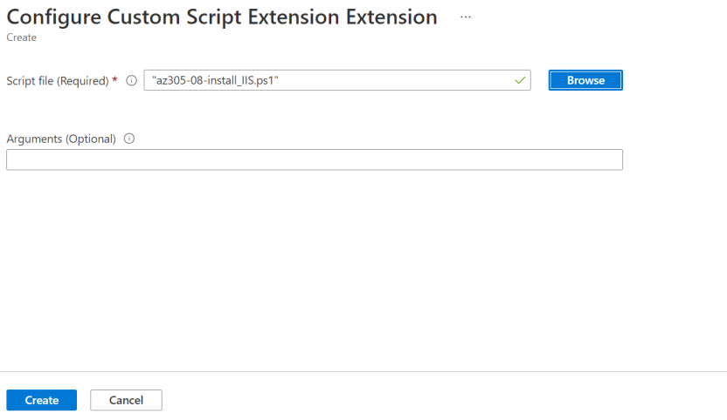

- Under the Settings section, click on Instances, select the checkboxes next to the two instances, and click on Upgrade
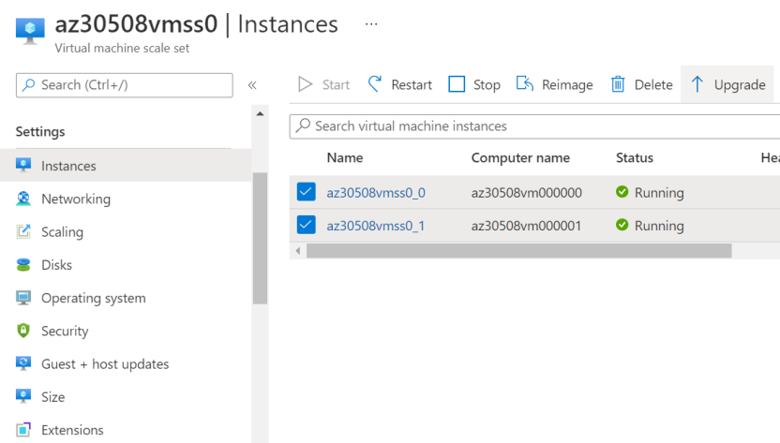

- Now, type Load balancers in the search bar and select it
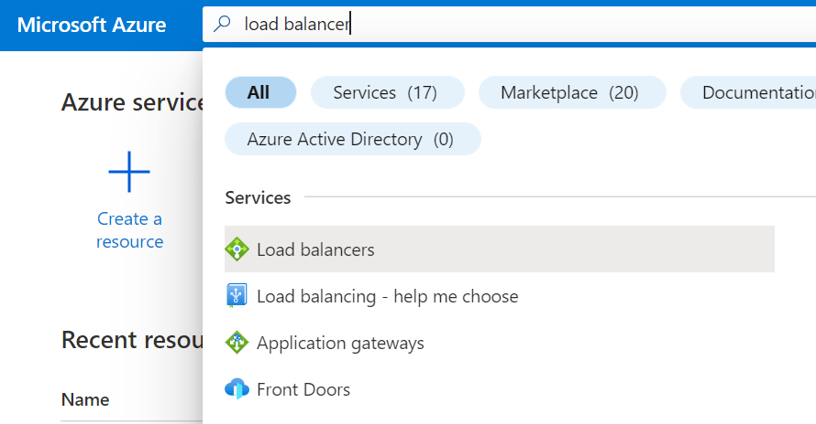

- Select the load balancer that you created

- Under Settings, select Frontend IP Configuration

- Note the value of the Public IP address assigned
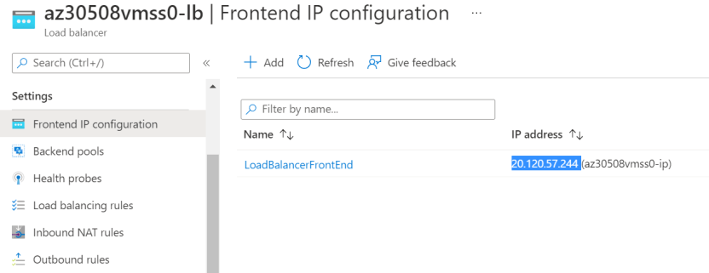

- Open a new browser tab and navigate to that IP address
